Goals of the Teaching Learning Process Training:
To establish a sustainable system driven quality improvement mechanisms in pre-service nursing education to produce the capable nurses who can perform what they are expected to perform and to become a hub for quality nursing education in the country/world.
Objectives of the Training : By the end of this training, the learners
- Describe the importance of educating health care providers.
- Demonstrate essential and effective teaching skills to produce competent students. Competencies to be developed by the end of the training:
- KNOWLEDGE :
- Interpret the need of improving the quality of nursing educational institutions.
- Outline the different components of effective teaching.
- SKILLS :
- Illustrate the different components of effective teaching (Demonstration, Facilitation, Role play, Simulation).
- Demonstrate mentoring skills (Coaching, Feedback, Problem solving , Conflict management).
- ATTITUDE :
- Perform roles and responsibilities as a trainer.
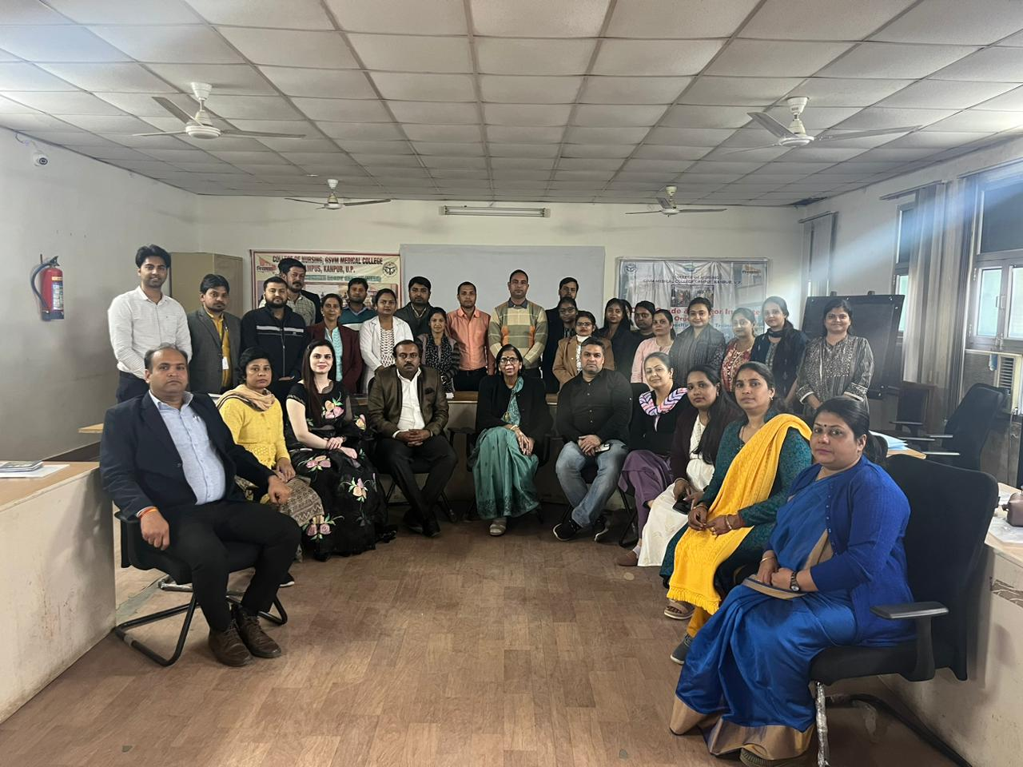
The three days TLP program was scheduled from 21/02/2024 to 23/02/2024 for all the three given competencies that is KNOWLEDGE, SKILL AND ATTITUDE The program was started with the registrations of the candidates . 24 candidates were registered for this program from the college Suruchi Institute of Nursing , Lucknow, Vimla College of Nursing , Kanpur, Lucknow Institute of Nursing , Lucknow , Yashraj Institute of professional studies, Charak College of Nursing Lucknow, Dr. Mahendra Kumar chotelal bind College of Nursing and paramedical sciences Prayagraj , S.S. Institute of Nursing Lucknow, Sai College of Medical Sciences and Technology Kanpur, Signa College of Nursing Kanpur, GSRM College of Nursing Lucknow, Nirmala Institute of Nursing and Paramedical Science Hardoi. Program was started by the registration and self assessment. Inauguration was done by Prof. Naveena JH Vice Principal by explaining about the Mission Niramaya. Dr. Akansha Massey welcomed the participants and Mr. Javed Ansari overview the training agenda to the participants. There were 6 more facilitator Prof. Namita Batra, Mr. Subhash Sharma, Mrs. Lithiya Jose, Mrs. Beena Peter , Mrs. Renu Tripathi, Ms. Manisha Anand, Mrs. Priyanka Sachan. The different topics regarding assessment of knowledge, skill and attitude were given to all the facilitator . During the sessions there were many activities happened during the three days program participant involved in the hand on activities and in the demonstrations.

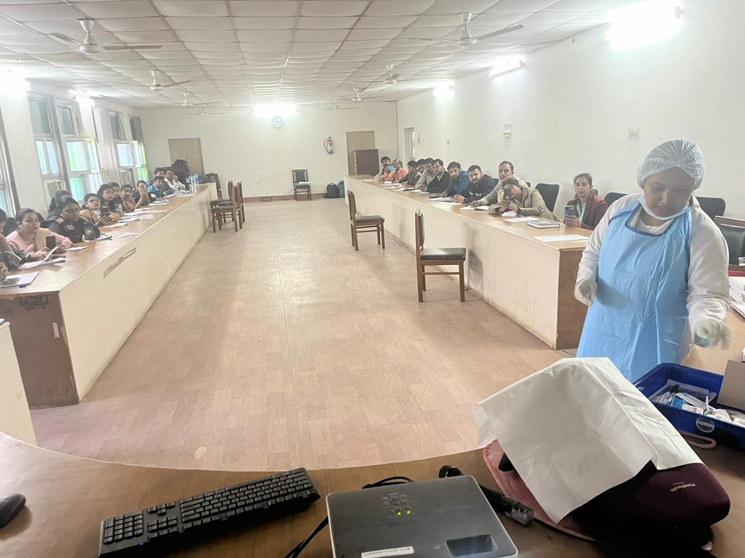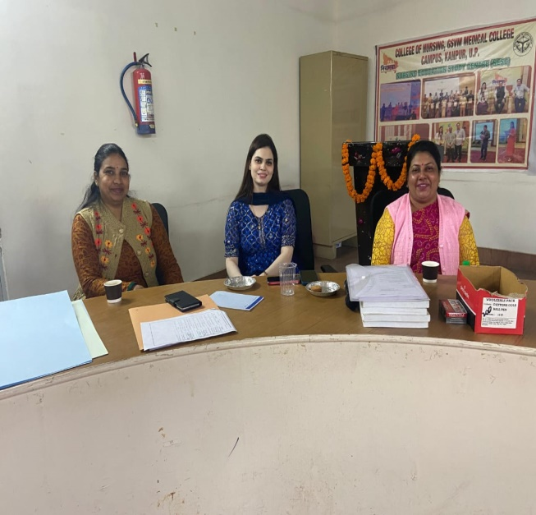

On the end day of the program was summarized by Mrs. Lithiya Jose and the post knowledge assessment was done by Dr. Akansha Massey . Valedictory session was given by the Principal of the college Lt. Col. Dr. Karesh Prasad Madam and TLP program was ended bt vote of thanks.